How to choose between the Xiaomi Redmi Airdots and Tronsmart Spunky Beat?
Choosing the best TWS earbuds for your money.
Last year, the TWS earbuds market suddenly broke out like the shoots after the rain. There are lots of companies that have started to do TWS earbuds. In the TWS market the most famous brands are Apple AirPods and Xiaomi Redmi Airdots. The former is the most expensive, and the latter is the cheapest in the market. As it’s known, Xiaomi is always famous for its high performance, but for TWS earbuds, is it still the same? I recently found out about a Qualcomm TWS earbuds boost in the market called the Tronsmart Spunky Beat. Many readers ask me how to choose between these two earbuds. So today I am going to make a comparison between these two TWS earbuds. The decision is on your mind.

Price
The Xiaomi Redmi Airdots is 25.99 USD and the Tronsmart Spunky Beat is 24.99 USD. Almost the same price, the Xiaomi Redmi Airdots is $1 more expensive which is not a problem.

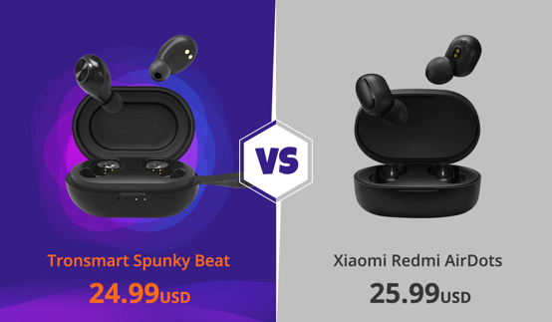

Bluetooth chip
The Xiaomi Redmi Airdots uses Realtek which is the middle-class chip. The Tronsmart Spunky Beat uses the Qualcomm chip which is the highest class in the market now. There are three main chip solutions in the market now. The cheapest one is Jieli, followed by Realtek and then the best one is Qualcomm. So, from this point, Tronsmart Spunky Beat earns 1 point. Qualcomm chip brings the earbuds lower latency, more stable connection and higher resolution sound. Both earbuds use Bluetooth 5.0, but with Qualcomm chip, Tronsmart Spunky Beat has a better connection.
Sound
Talking about the sound, different people have different understanding according to their own favorite music style. But if you are talking about the sound quality, you need to take the specification as reference. Xiaomi Redmi Airdots supports AAC & SBC file, while Tronsmart Spunky Beat supports aptXTM and AAC & SBC. AptX does a better job of compressing and decompressing your music, and is less of a drain on your battery. AptX also introduces less delay—or latency—than other codecs, which comes in handy if you wear wireless headphones while watching videos or playing games on your mobile device. It means that Troonsmart Spunky Beat provides lossless sound. In this case, Tronsmart Spunky Beat has better sound quality than Xiaomi Redmi Airdots. But please note that aptX audio only for those compatible Android devices.
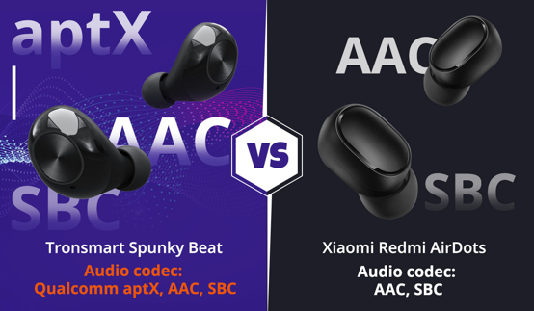
About the noise-canceling technology, Xiaomi Redmi Airdots supports DSP noise canceling, while Tonsmart Spunky Beat supports both cVc 8.0 and DSP. DSP noise canceling refers to cancelling out the background noise when you play music, while cVc 8.0 refers to clearing the noise when you talk on the phone so that the other side of the phone can hear your voice more clearly.
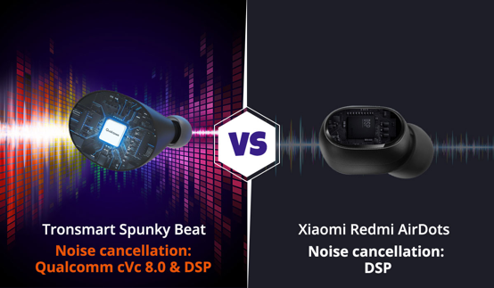
Design
Both earbuds have an egg-shape design; Tronsmart Spunky Beat has a built-in hanging strap which is more convenient when you bring it out. You can hook it even on your key chain.
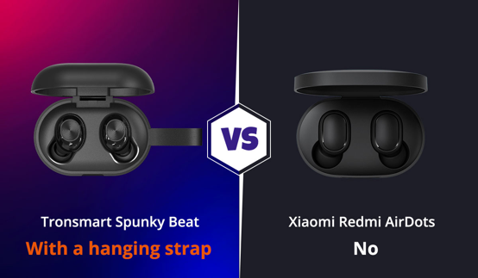

For the charging port, the Xiaomi Redmi Airdots supports Micro USB, while the Tronsmart Spunky Beat supports type-C and has an integrated charging cable that allows you to charge your earbuds anywhere without taking an extra cable with you. You can choose to charge your earbuds via the integrated USB cable or type-C charging port for fast charge.
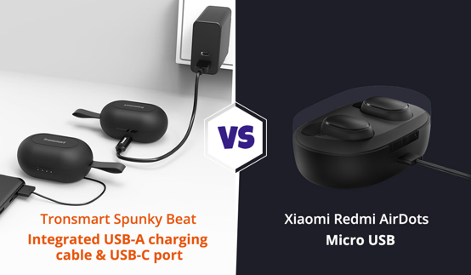
The Xiaomi Redmi Airdots is designed with pressured button control, which I don’t like much when you press it and your ear feels uncomfortable from the pressure, but of course it has no latency. The Tronsmart Spunky Beat is designed with intuitive touch control, which you will not feel it when you change the song or use other function, from this point; I like the Tronsmart Spunky Beat more. Thus, Tronsmart Spunky Beat is more convenient to use.
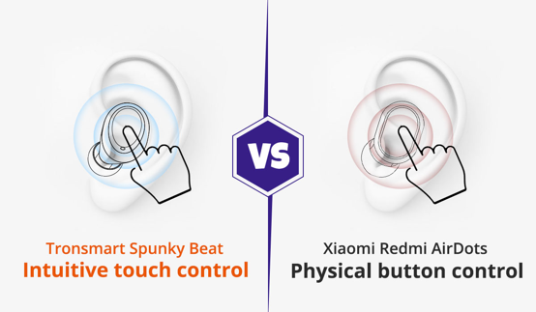
Both earbuds support voice assistant and IPX5 waterproof. Tronsmart Spunky Beat also has battery indicator for charging case.

Plus, Xiaomi Redmi Airdots can play up to 12 hours and Tronsmart Spunky Beat can play up to 24 hours. This is also one of the reasons why I like Tronsmart Spunky Beat.
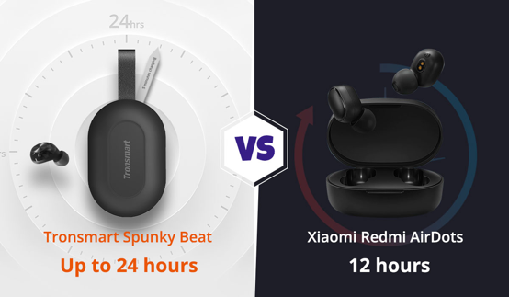
I think there is also one important feature I need to point out that Tronsmart Spunky Beat supports one earbud listening. It means that you can pair two different mobile phones or digital audio player at one time. It is really cool when I use one earbud to talk on the phone, and my friend uses the other one to listen to music.
Conclusion
Above all, Tronsmart Spunky Beat has higher performance considering the Qualcomm chip, comfortable design, lossless sound quality, and up to 24 hours play time. If you ask me how to choose Xiaomi Redmi Airdots and Tronsmart Spunky Beat, I would definitely recommend Tronsmart Spunky Beat. For easy understanding, here I make a comparison sheet for your reference.

Tronsmart Spunky Beat: (Link)
Xiaomi Redmi Airdots: (Link)
